Number of nodes: 92969

Number of edges: 5299404

Average degree: 114.0037

Players with the most connections:

Team Degree

1 L. Clarke Feb 10, 1985 801

2 Renato Cajá Sep 15, 1984 801

3 Roger Jan 7, 1985 794

4 Guilherme Santos Feb 5, 1988 792

5 Wellington Paulista Apr 22, 1984 781

6 Jael Oct 30, 1988 779

7 C. O'Grady Jan 25, 1986 739

8 A. Hammill Jan 25, 1988 727

9 S. Ribas Mar 11, 1988 722

10 Marquinho Jul 3, 1986 722

92961 H. Vigna Apr 26, 1977 19

92962 G. Rivero Mar 12, 1975 19

92963 J. Pizarro Feb 22, 1996 19

92964 P. Pechenkin Jan 30, 1991 19

92965 A. Dmitrijev Feb 18, 1982 19

92966 G. Giacopetti May 6, 1992 19

92967 I. Drannikov Jul 22, 1986 19

92968 A. Ndour Oct 21, 1997 19

92969 I. Quirino Jan 11, 1985 19

Average shortest path length: 3.239966905081478

Network density: 0.001226267948601347

Diameter: 6

Triadic closure: 0.25021513906117365

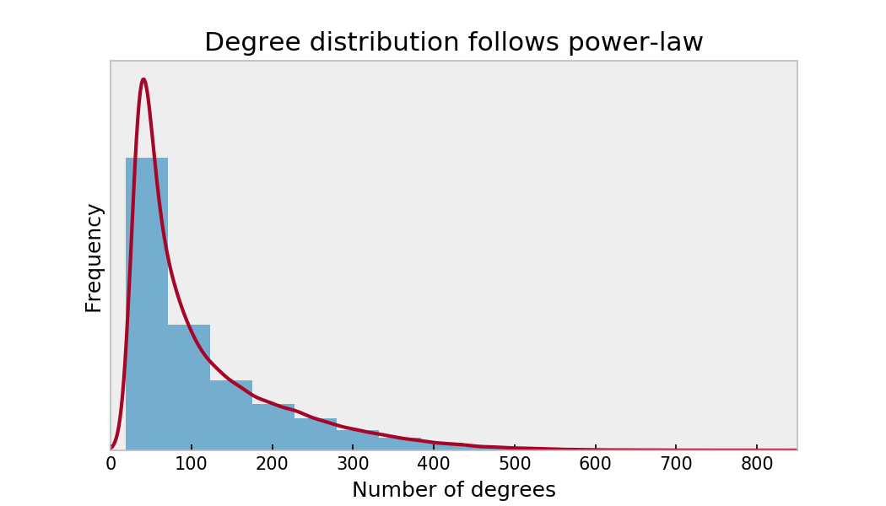

The most important players according to the eigenvectors:

0 1

1 Wellington Paulista Apr 22, 1984 0.045608

2 Roger Jan 7, 1985 0.043694

3 Patric Mar 25, 1989 0.040132

4 Egídio Jun 16, 1986 0.038936

5 Gilson May 14, 1986 0.038357

6 F. Menezes Jan 20, 1988 0.038315

7 M. Leite Aug 3, 1988 0.037915

8 Renato Cajá Sep 15, 1984 0.037864

9 T. Real Jan 26, 1989 0.037168

10 H. Almeida May 27, 1991 0.037048

11 Guilherme Santos Feb 5, 1988 0.036953

12 Marquinhos Gabriel Jul 21, 1990 0.036597

13 Jonas Feb 10, 1987 0.036546

14 R. Oliveira Dec 29, 1989 0.035759

15 Diego Souza Jun 17, 1985 0.035522

16 Wesley Jun 24, 1987 0.035099

17 Wellington Saci Jan 5, 1985 0.034965

18 Jael Oct 30, 1988 0.034914

19 Thiago Heleno Sep 17, 1988 0.034846

20 B. Silva Aug 3, 1986 0.034809

21 Giovanni Augusto Sep 5, 1989 0.034614

22 Rafael Moura May 23, 1983 0.034559

23 M. Oliveira Mar 29, 1987 0.034490

24 A. Lima May 3, 1985 0.034295

25 Alecsandro Feb 4, 1981 0.034144

26 Ayrton Apr 19, 1985 0.033950

27 Marinho May 29, 1990 0.033919

28 Rildo Mar 20, 1989 0.033873

29 Felipe May 28, 1990 0.033614

30 Carlos Alberto Dec 11, 1984 0.033608

The most important players according to betweenness:

0 1

1 D. González Jul 20, 1982 0.002210

2 S. Yun Feb 13, 1990 0.001652

3 C. Kazim-Richards Aug 26, 1986 0.001638

4 B. Khumalo Jan 6, 1987 0.001343

5 S. Ribas Mar 11, 1988 0.001249

6 K. Dikgacoi Nov 24, 1984 0.001118

7 E. Ledesma May 24, 1988 0.001110

8 A. Jaakkola Mar 13, 1987 0.001089

9 Jô Mar 20, 1987 0.001035

10 K. Erasmus Jul 8, 1990 0.001006

11 A. Prijovic Apr 21, 1990 0.000949

12 A. Mierzejewski Nov 6, 1986 0.000947

13 D. Arismendi Jan 25, 1988 0.000926

14 L. Ríos Nov 17, 1982 0.000874

15 K. Grosicki Jun 8, 1988 0.000873

16 M. Arteaga Jun 17, 1994 0.000862

17 B. Moon Apr 6, 1986 0.000854

18 M. Zárate Mar 18, 1987 0.000851

19 C. McCormack May 18, 1990 0.000851

20 J. Mosquera Jan 15, 1988 0.000848

21 F. Bastians May 9, 1988 0.000839

22 N. Papa Waigo Jan 20, 1984 0.000839

23 Kayke Apr 1, 1988 0.000825

24 G. Jara Aug 29, 1985 0.000820

25 D. Fabbrini Jul 31, 1990 0.000820

26 T. Kupisz Jan 2, 1990 0.000817

27 Z. Zlamal Nov 5, 1985 0.000813

28 Á. Peña Dec 25, 1989 0.000806

29 S. Abreu Oct 17, 1976 0.000804

30 J. Mutch Dec 2, 1991 0.000801

Players Weight

1 ['A. Glowacki Mar 13, 1979', 'P. Brozek Apr 21... 18

2 ['P. Malecki Aug 1, 1988', 'P. Brozek Apr 21, ... 16

3 ['V. Corluka Feb 5, 1986', 'A. Miranchuk Oct 1... 16

4 ['S. Ramos Mar 30, 1986', 'Marcelo May 12, 1988'] 15

5 ['A. Dzagoev Jun 17, 1990', 'G. Schennikov Apr... 14

6 ['G. Chiellini Aug 14, 1984', 'G. Buffon Jan 2... 14

7 ['G. Schennikov Apr 27, 1991', 'A. Dzagoev Jun... 14

8 ['I. Akinfeev Apr 8, 1986', 'G. Schennikov Apr... 14

9 ['J. Torres Nilo Jan 16, 1988', 'H. Ayala Mar ... 14

10 ['P. Hanlon Jan 20, 1990', 'L. Stevenson Jan 5... 14

11 ['A. Ljevakovic Aug 7, 1984', 'T. Vondrasek Oc... 13

12 ['C. Lustenberger Jan 6, 1987', 'D. Zibung Jan... 13

13 ['C. Wingert Jun 16, 1982', 'K. Beckerman Apr ... 13

14 ['D. Massey Apr 17, 1988', 'C. Shields Dec 27,... 13

16 ['G. Piqué Feb 2, 1987', 'L. Messi Jun 24, 1987'] 13

17 ['J. Hong May 21, 1988', 'C. Choi Feb 8, 1987'] 13

18 ['K. Beckerman Apr 23, 1982', 'N. Rimando Jun ... 13

19 ['L. Messi Jun 24, 1987', 'S. Busquets Jul 16,... 13

20 ['N. Rimando Jun 17, 1979', 'K. Beckerman Apr ... 13

21 ['S. Busquets Jul 16, 1988', 'L. Messi Jun 24,... 13

22 ['T. Grigar Feb 1, 1983', 'T. Vondrasek Oct 26... 13

23 ['T. Vondrasek Oct 26, 1987', 'T. Grigar Feb 1... 13

24 ['V. Denisov Feb 23, 1987', 'A. Miranchuk Oct ... 13

25 ['A. Berezutski Jun 20, 1982', 'I. Akinfeev Ap... 12

26 ['A. Berezutski Jun 20, 1982', 'V. Berezutski ... 12

27 ['A. Dzagoev Jun 17, 1990', 'K. Nababkin Sep 8... 12

28 ['A. Meier Jan 17, 1983', 'M. Russ Aug 4, 1985'] 12

29 ['C. Brunt Dec 14, 1984', 'J. Morrison May 25,... 12

30 ['C. Gunter Jul 21, 1989', 'G. McCleary May 15... 12

31 ['C. Wondolowski Jan 28, 1983', 'S. Salinas Ju... 12

32 ['D. Kolar Oct 27, 1985', 'D. Limbersky Oct 6,... 12

33 ['D. Onyango May 15, 1985', 'H. Kekana May 23,... 12

34 ['F. Peluso Jan 20, 1984', 'A. Consigli Jan 27... 12

35 ['G. McCleary May 15, 1987', 'C. Gunter Jul 21... 12

36 ['G. Zusi Aug 18, 1986', 'M. Besler Feb 11, 19... 12

37 ['H. Kekana May 23, 1985', 'D. Onyango May 15,... 12

38 ['H. Mizumoto Sep 12, 1985', 'K. Morisaki May ... 12

39 ['I. Agirretxe Feb 24, 1987', 'X. Prieto Aug 2... 12

40 ['I. Akinfeev Apr 8, 1986', 'S. Ignashevich Ju... 12

41 ['I. Akinfeev Apr 8, 1986', 'K. Nababkin Sep 8... 12

42 ['J. Corona Jan 26, 1981', 'J. Domínguez Nov 8... 12

43 ['J. Forrest Jul 7, 1991', 'S. Brown Jun 25, 1... 12

44 ['J. Lascelles Nov 11, 1993', 'K. Darlow Oct 8... 12

45 ['J. Rivas Oct 18, 1984', 'M. Viniegra Apr 26,... 12

46 ['K. Beckerman Apr 23, 1982', 'T. Beltran Oct ... 12

47 ['K. Benzema Dec 19, 1987', 'Marcelo May 12, 1... 12

48 ['K. Darlow Oct 8, 1990', 'J. Lascelles Nov 11... 12

49 ['K. Nababkin Sep 8, 1986', 'G. Schennikov Apr... 12

50 ['L. Baines Dec 11, 1984', 'P. Jagielka Aug 17... 12

Longest serving players at one club:

Name Team

S. Kim Ulsan Hyundai 33

J. Kim Pohang Steelers 32

D. Kim Incheon United 31

J. Lee Jeonnam Dragons 26

Incheon United 26

S. Lee Pohang Steelers 25

D. Kim Pohang Steelers 25

J. Lee Jeonbuk Hyundai Motors 24

J. Kim Incheon United 24

J. Hwang Pohang Steelers 23

Y. Kim Ulsan Hyundai 23

J. Kim FC Seoul 22

J. Lee Ulsan Hyundai 22

S. Lee FC Seoul 22

J. Kim Gyeongnam FC 22

S. Lee Jeonbuk Hyundai Motors 22

X. Zhang Beijing Sinobo Guoan 22

J. Kim Jeonbuk Hyundai Motors 21

D. Kim Seongnam FC 20

Suwon Samsung Bluewings 20

S. Kim Jeju United 20

Jeonbuk Hyundai Motors 20

J. Kim Gangwon FC 20

S. Lee Jeonnam Dragons 20

K. Lee Pohang Steelers 20

S. Lee Suwon Samsung Bluewings 20

S. Kim Seongnam FC 18

J. Lee Gyeongnam FC 18

P. Brozek Wisla Kraków 18

W. Kim FC Seoul 18

J. Hong Jeonbuk Hyundai Motors 18

H. Kim FC Seoul 18

J. Lee Gangwon FC 17

Gimcheon Sangmu 17

K. Kim Pohang Steelers 17

C. Kim FC Seoul 16

H. Kim Jeju United 16

A. Miranchuk Lokomotiv Moscow 16

C. Choi Jeonbuk Hyundai Motors 16

M. Kim Jeonnam Dragons 16

A. Caracciolo Brescia Calcio 16

S. Lee Ulsan Hyundai 16

J. Lee Seongnam FC 16

J. Park Seongnam FC 16

J. Lee Suwon Samsung Bluewings 16

S. Ameobi Newcastle United 15

L. Messi FC Barcelona 15

J. Park Daegu FC 15

J. Kim Suwon Samsung Bluewings 15

J. Domínguez CD Cruz Azul 15

dtype: int64

Players with the most clubs:

Team

Name

J. Rodríguez 75

A. González 75

Paulinho 70

J. García 69

J. Martínez 65

J. González 65

D. González 64

M. González 59

J. López 58

J. Hernández 57

M. Rodríguez 56

Gabriel 54

João Paulo 53

J. Silva 52

J. Gómez 51

J. Fernández 49

M. García 49

J. Brown 49

M. Pérez 48

R. García 47

Eduardo 47

C. González 47

D. Rodríguez 47

M. Fernández 47

J. Pérez 46

G. Rodríguez 46

Rafinha 46

A. Rodríguez 46

Adriano 45

F. Rodríguez 45

Douglas 44

Juninho 44

Felipe 43

S. García 43

J. Smith 42

A. Silva 42

A. Fernández 41

Leonardo 41

I. González 41

R. Martínez 41

R. Fernández 40

J. Ramírez 40

Ricardinho 40

A. Smith 40

A. López 40

J. Sánchez 39

A. Traoré 39

L. Silva 39

L. García 39

J. Castillo 39

Clubs with the most players:

Name

Team

Paraná Clube 432

Figueirense Futebol Clube 423

Clube Náutico Capibaribe 419

Red Bull Bragantino 416

Genoa CFC 410

Associação Atlética Ponte Preta 408

Oldham Athletic 399

Esporte Clube Vitória 389

Ascoli Calcio 385

Delfino Pescara 1936 368

Goiás Esporte Clube 367

Avaí Futebol Clube (SC) 362

Esporte Clube Bahia 362

Blackpool FC 361

Sport Club do Recife 359

Bradford City 355

Club Athletico Paranaense 354

Ceará Sporting Club 352

Club de Regatas Vasco da Gama 349

Northampton Town 348

Botafogo de Futebol e Regatas 344

Parma Calcio 1913 338

Charlton Athletic 332

Vila Nova Futebol Clube (GO) 331

Coritiba Foot Ball Club 329

Yeovil Town 328

Chievo Verona 326

Shrewsbury Town 326

Barnsley FC 324

Atlético Clube Goianiense 323

Clube Atlético Mineiro 322

Portsmouth FC 322

Swindon Town 322

Cesena FC 321

Puebla FC 321

Torino FC 318

Carlisle United 318

Grêmio Foot-Ball Porto Alegrense 317

Sport Club Internacional 315

SSC Bari 313

Cruzeiro Esporte Clube 313

Cheltenham Town 312

Bologna FC 1909 311

Coventry City 311

Sociedade Esportiva Palmeiras 310

Accrington Stanley 310

Santos FC 309

FK Rostov 307

Bury FC 307

Udinese Calcio 307